**COMP2160**

**LAB 6: OpenWRT- Antenna & PT**

# WiFi Antenna Extension – Windsurfer

For this lab, you need to make your own “Windsurfer”. This is an easy and inexpensive way to extend your WRT54GL range by making its antennas directional.

Please check the following videos for more details:

<https://www.youtube.com/watch?v=Jmg_duJSeWM>

or

<https://www.youtube.com/watch?v=gnMFp4NYXXM>

After making your own Windsurfers (the finished product), submit a picture of your AP with Windsurfers.

* The windsurfer antenna booster template is on Brightspace. Make sure you write your name on both pieces on the designated boxes, and they are clearly visible and readable in the picture.
* It is very important to make sure when you print the template that the red square on top right corner of the template stays square.

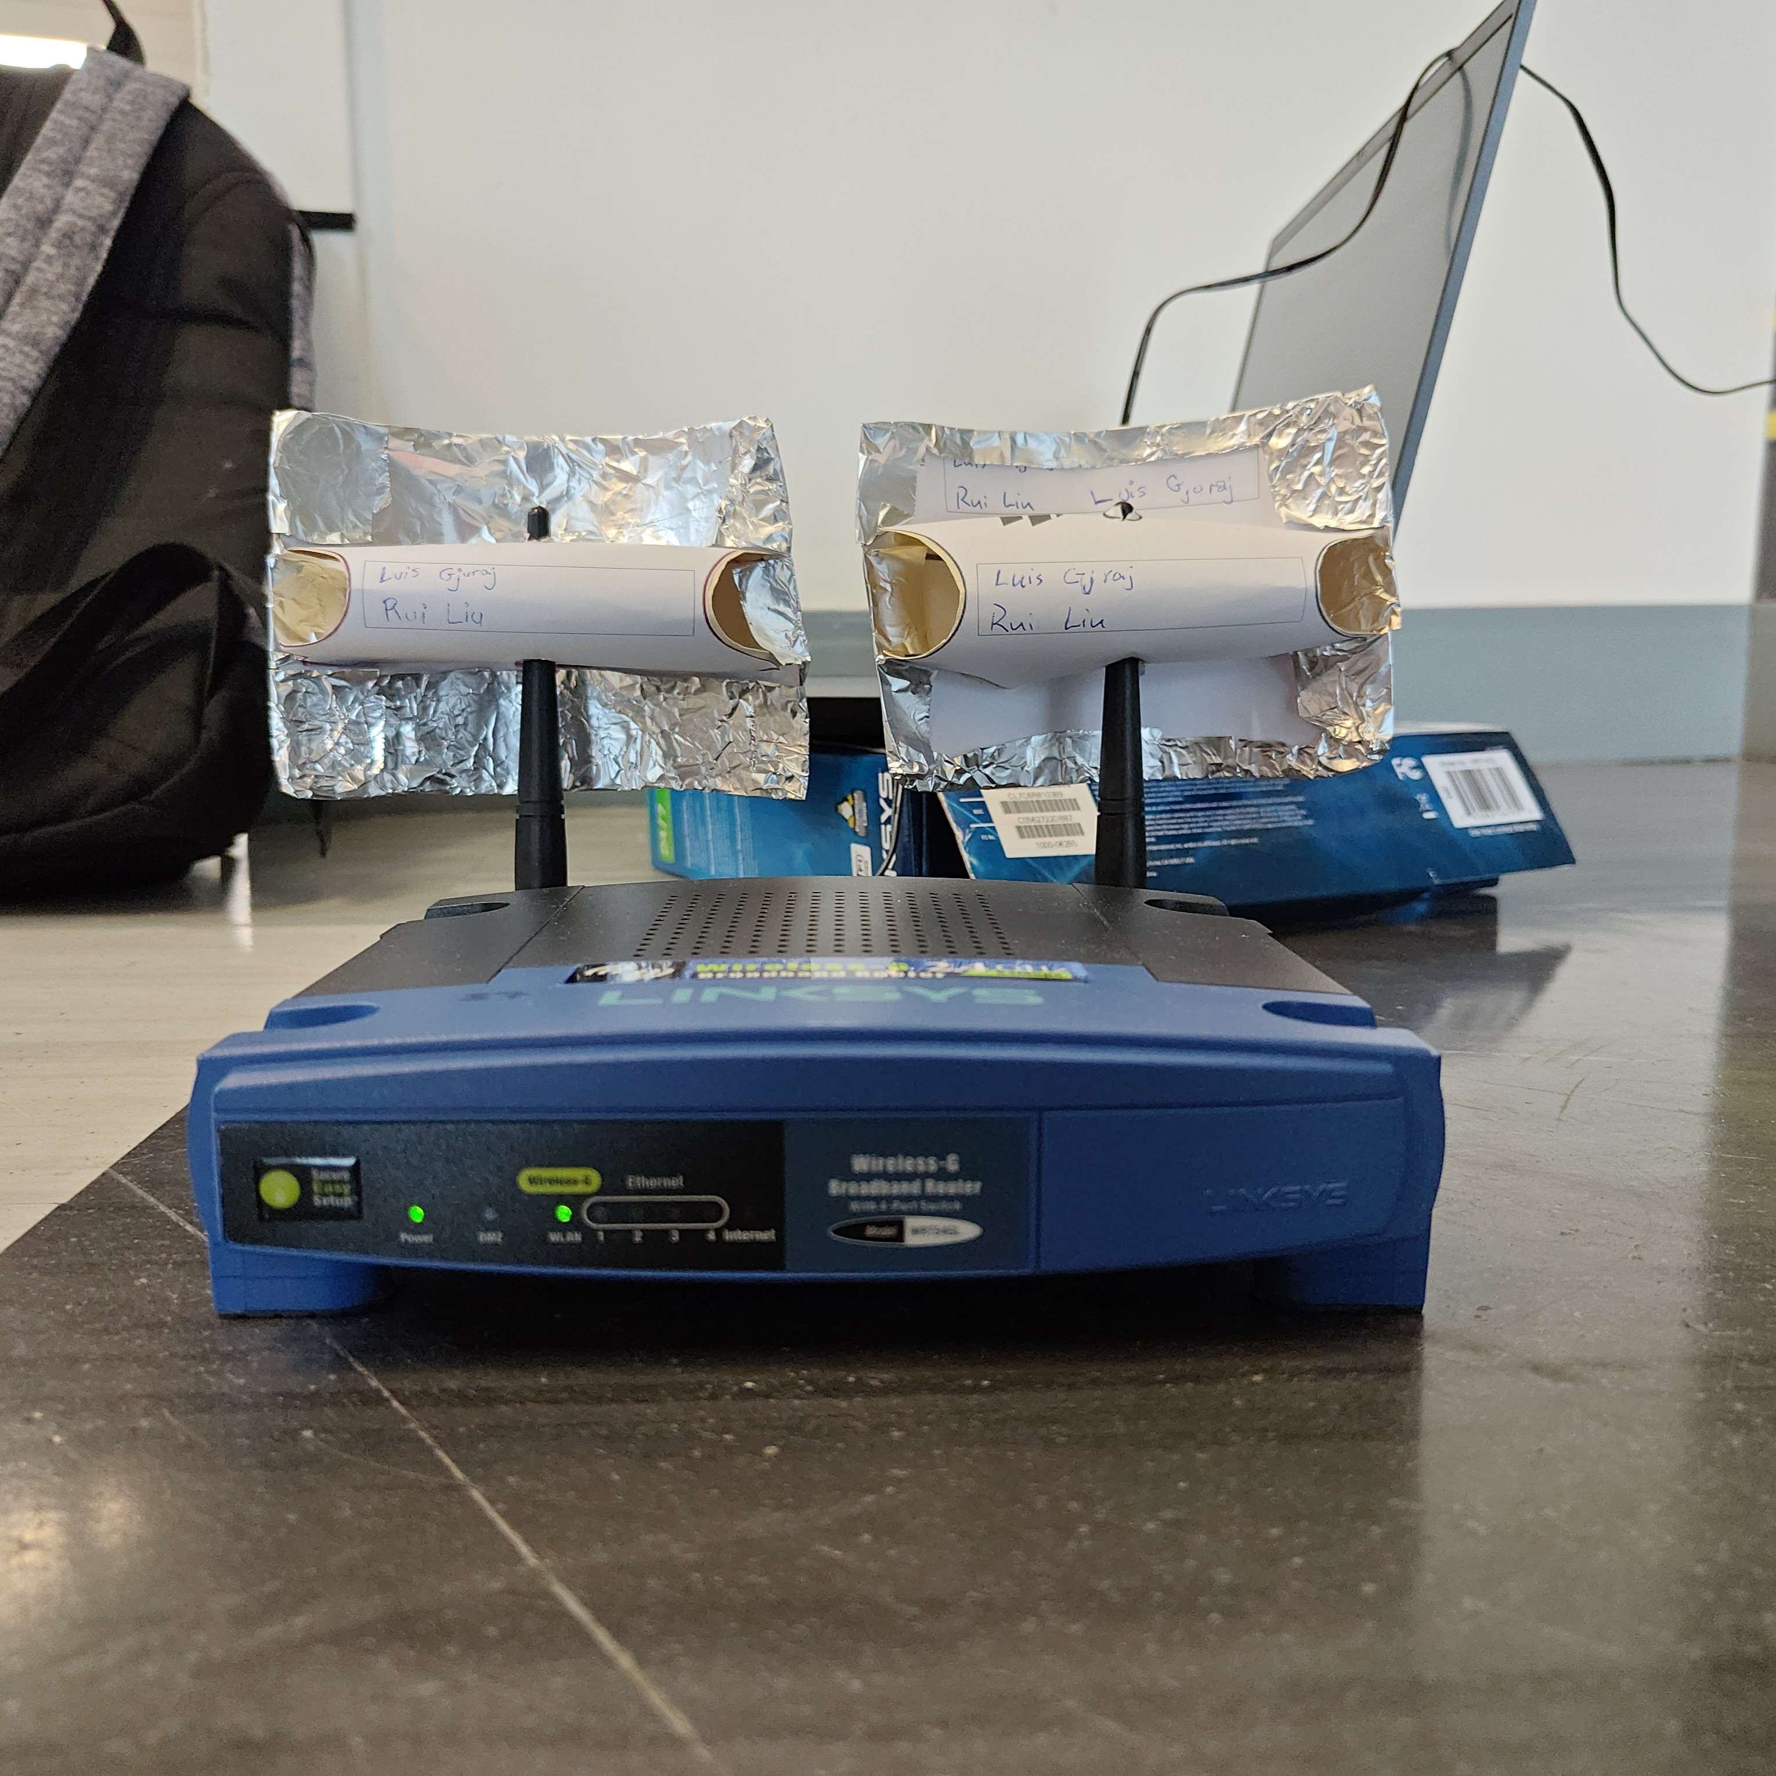

# Signal level measurement experiment

Now that you have successfully made your range booster let’s measure the signal strength with your laptop by using InSSider or wifi scanner at different distances from your AP.

To make sure the experiment is repeatable we want to measure the signal strength at same distance intervals from the AP for everyone.

1. Provide the make and model of your laptop using the table below (google your laptop specs for the wireless adapter make)

|  |  |  |  |
| --- | --- | --- | --- |
| **Make** | **Model** | **Wireless adapter** | **OS** |
| Razer | Blade 15 2019 | Intel® Wi-Fi 6 AX200 160MHz | Windows 10 |

1. We are going to conduct this experiment in the hallway next to our classroom where we usually meet. Place your router on the floor at the end that has the handicap ramp. Here is a picture of the where you want to place it:

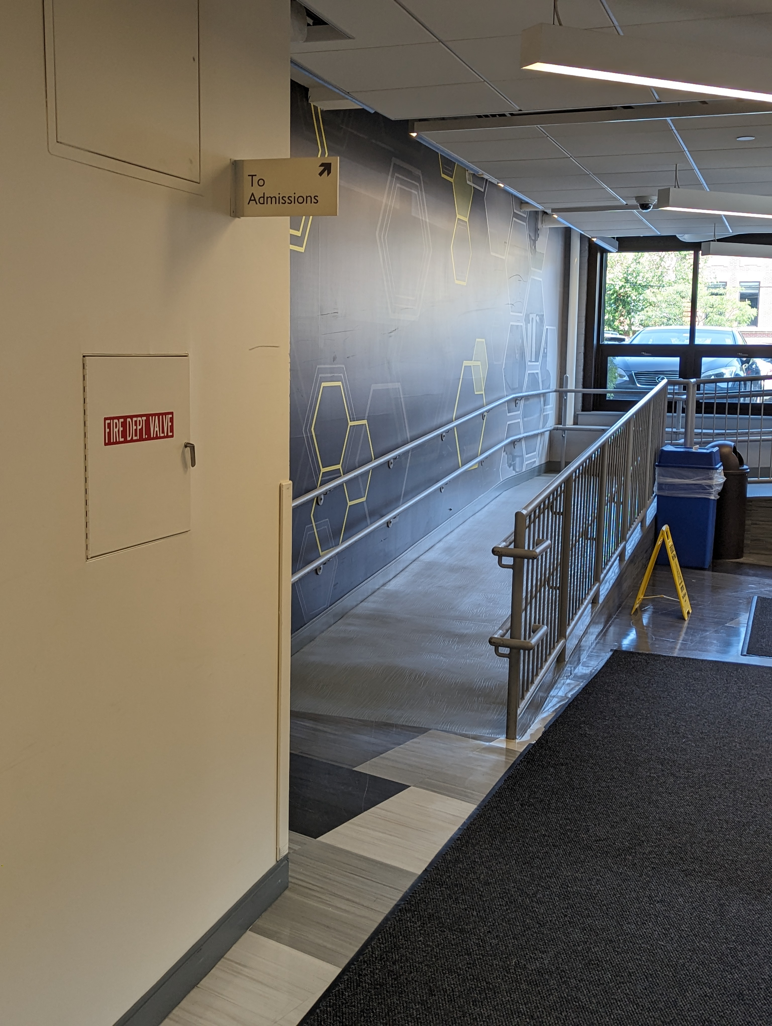

Power

AP

There is a couple of power outlet right around the corner.

1. Measure the signal strength at these four locations. Use the doors for your reference points (see pictures bellow):

* Power and control lab (007)
* Electrical Room 3-005
* Lab Service/Storage 3-003A
* Right under the “To West Lot” sign

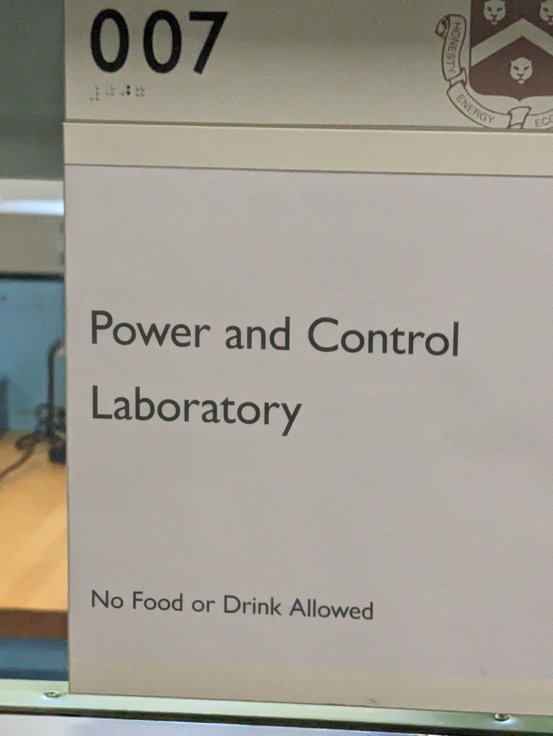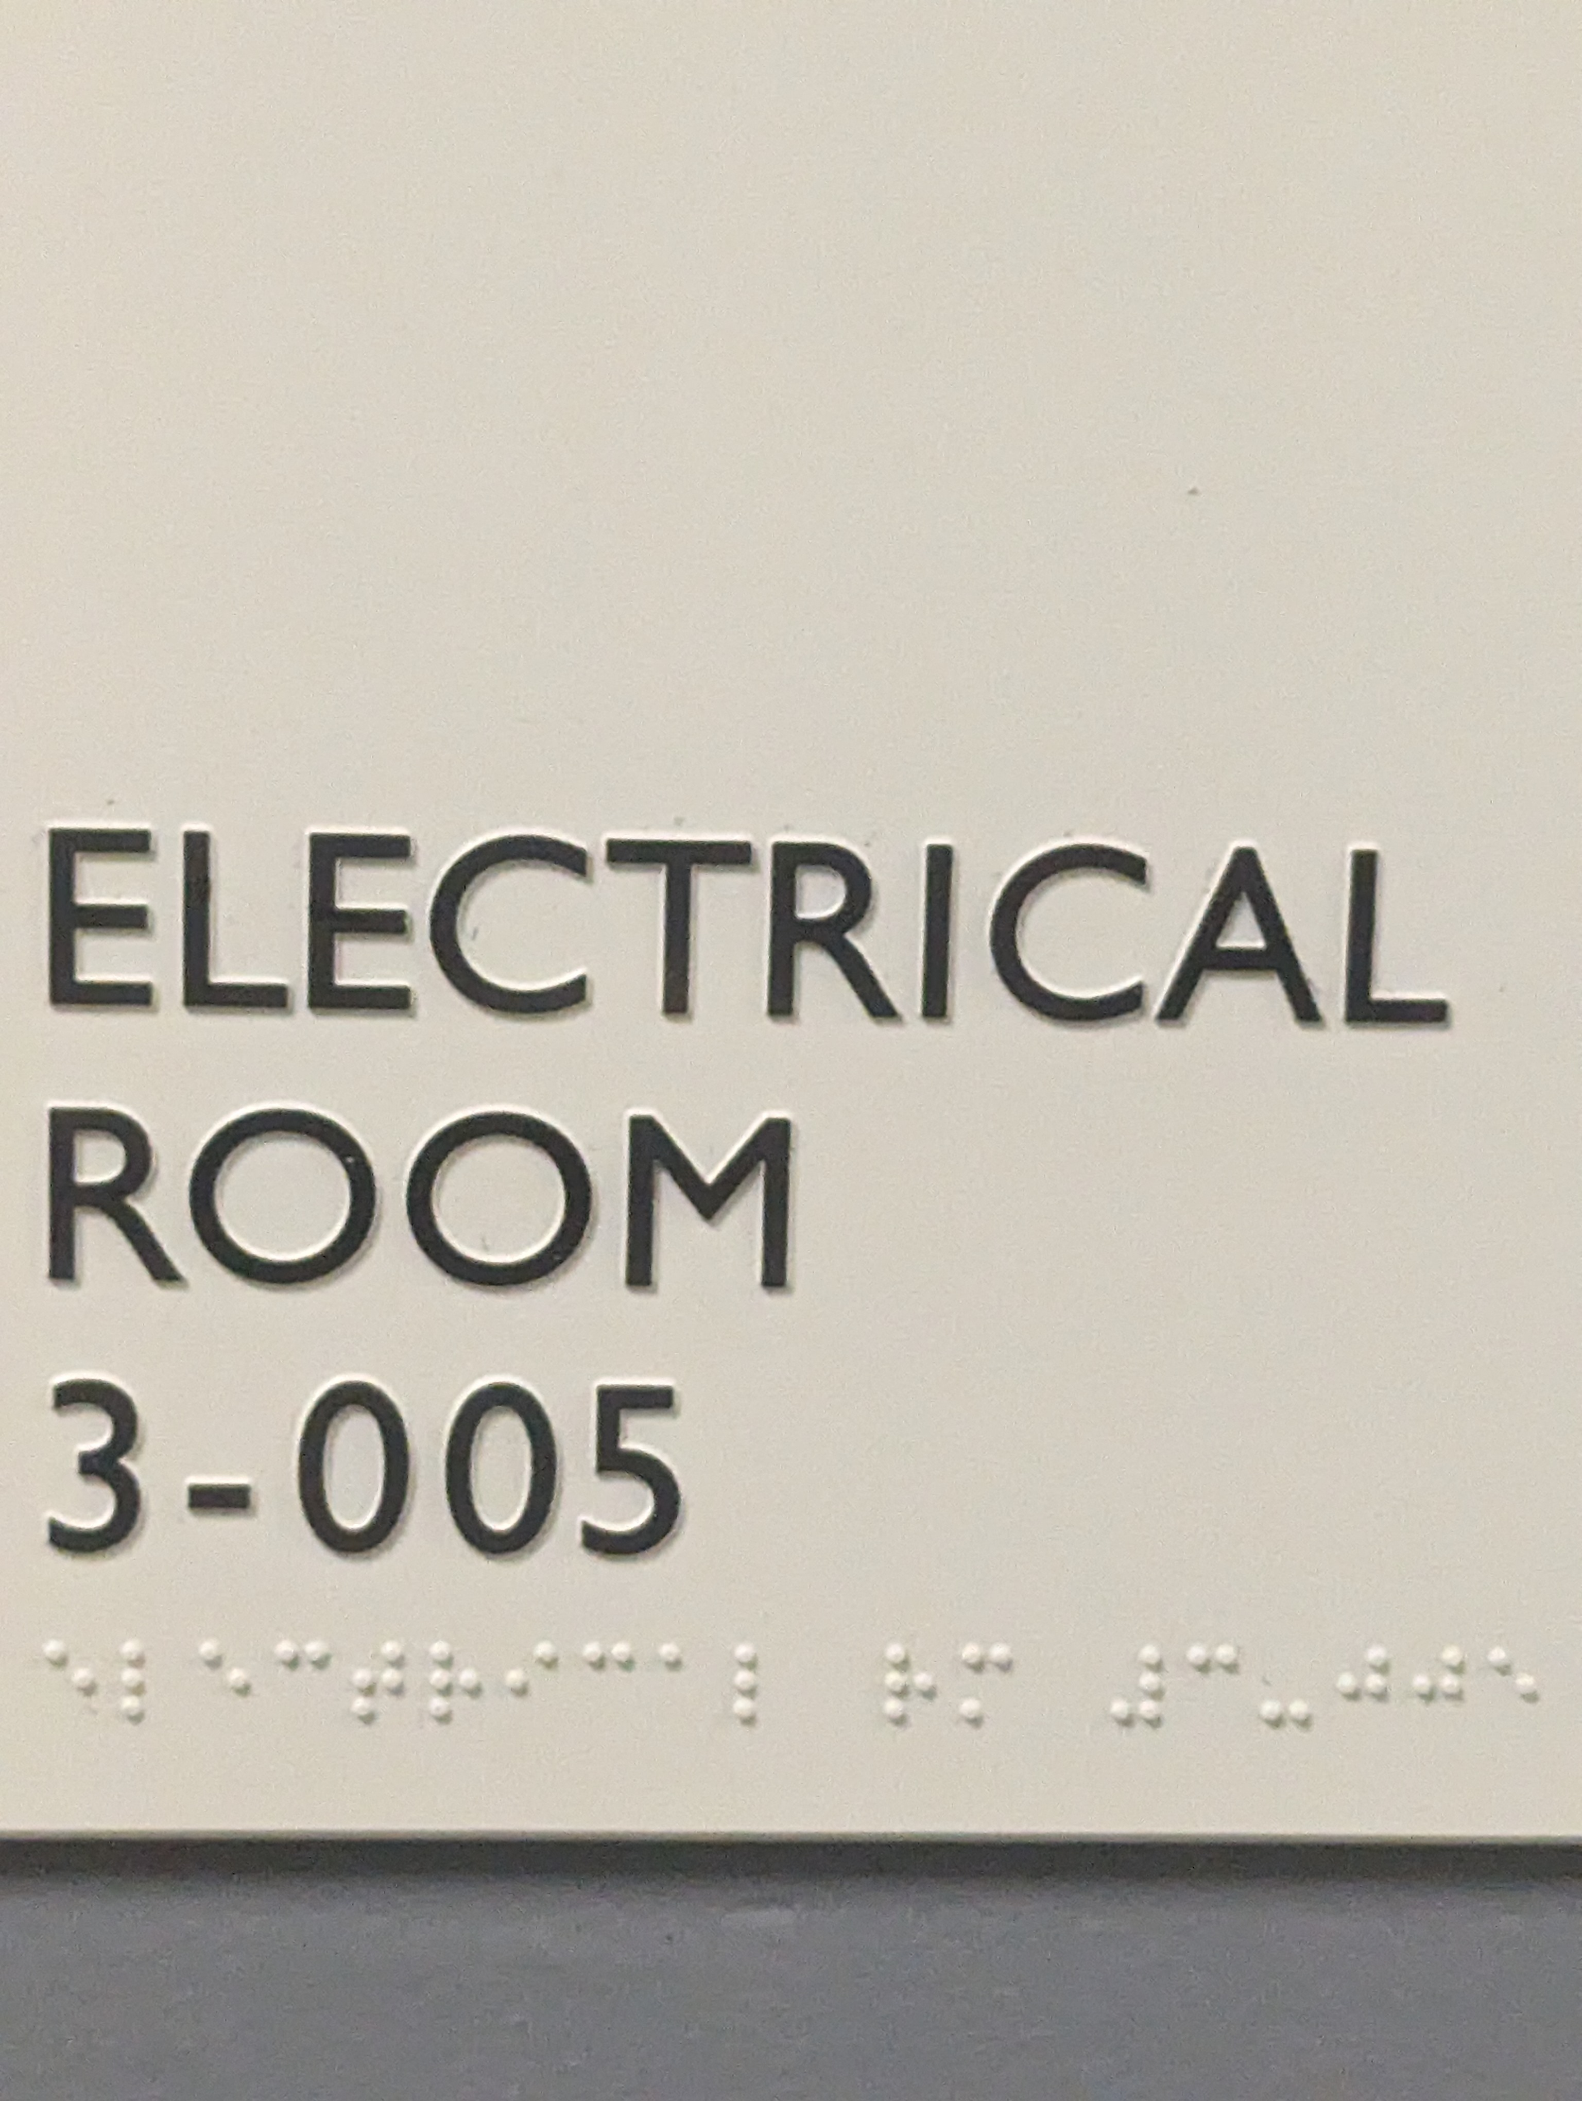

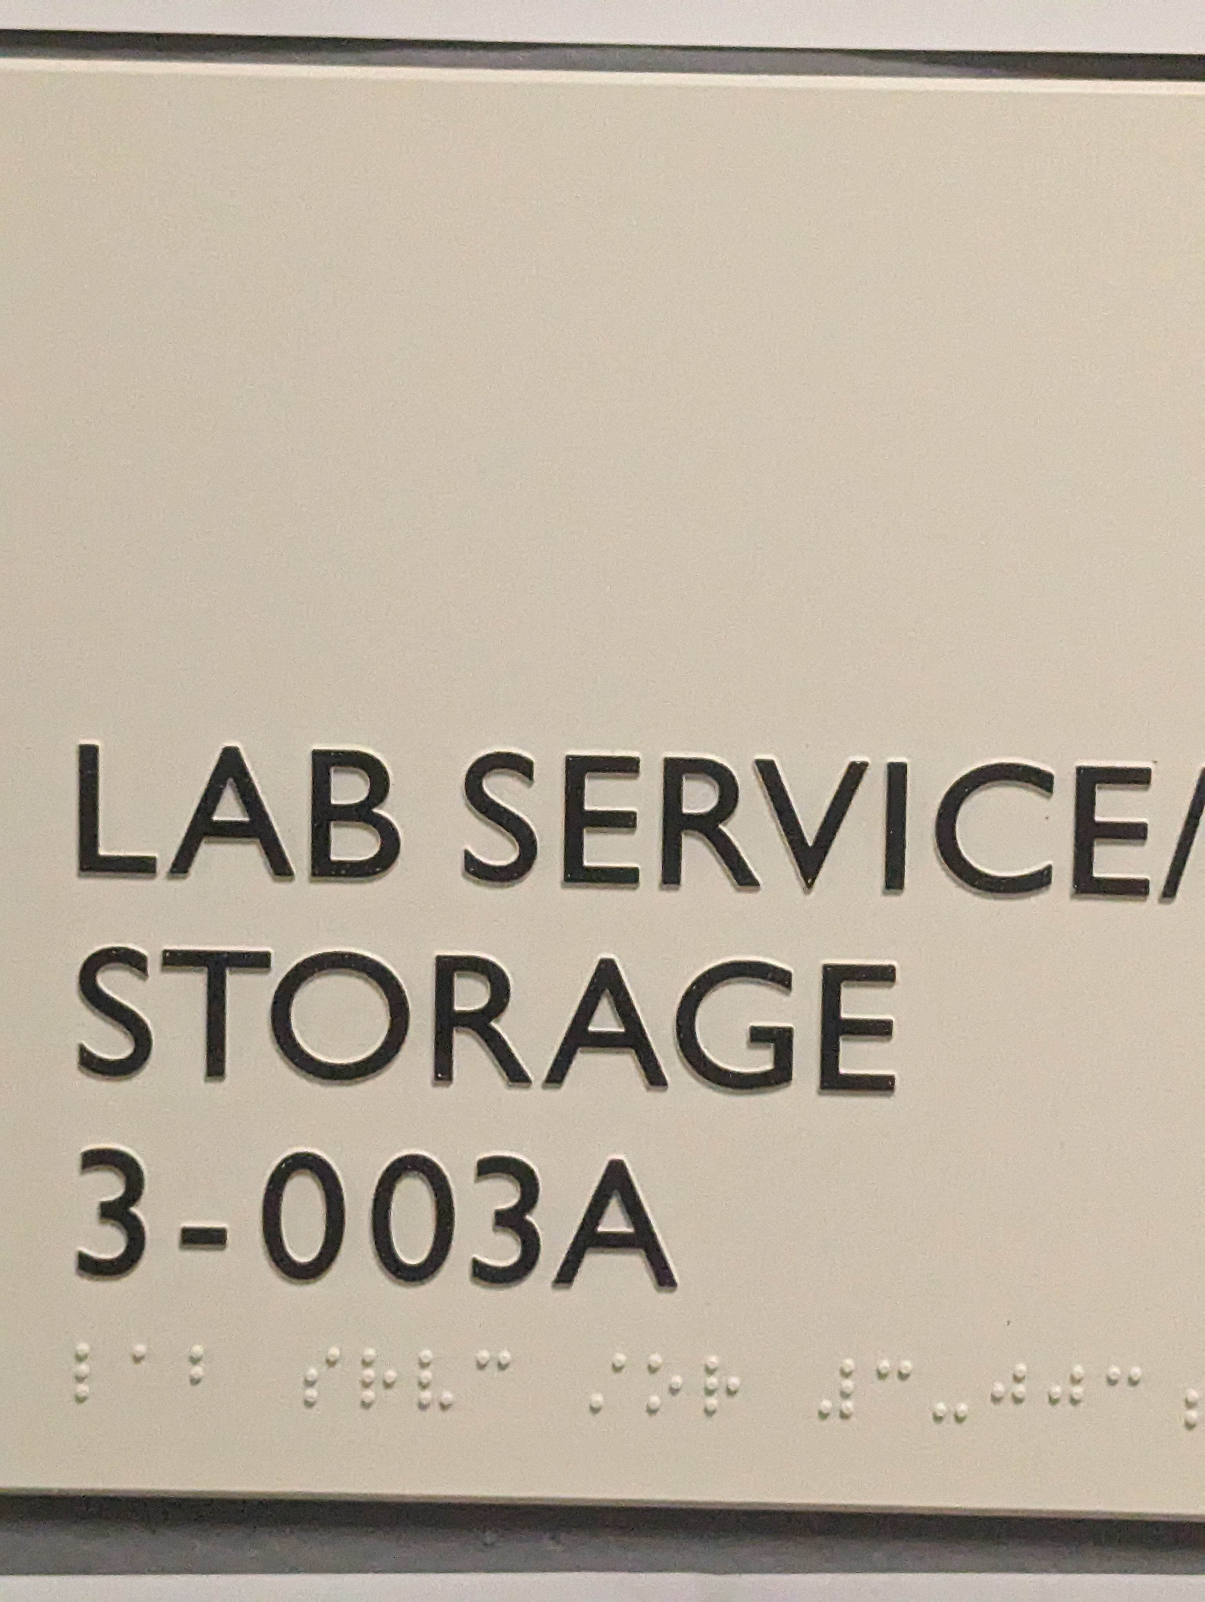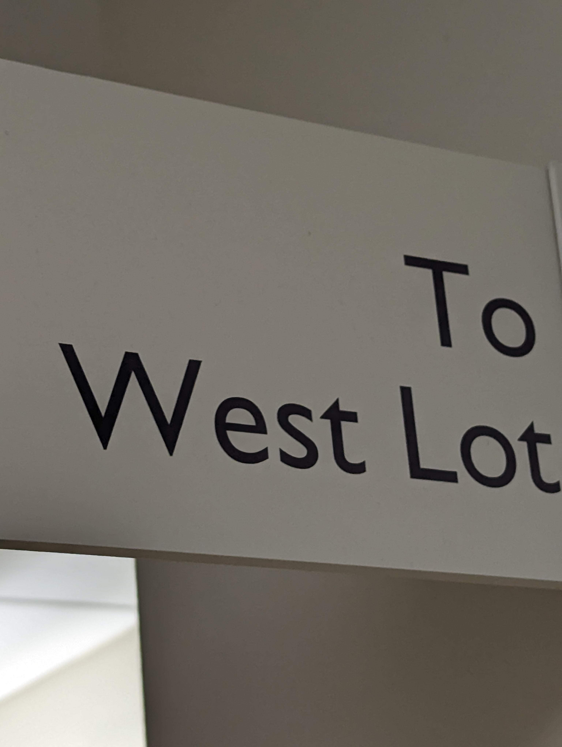

# Signal level measurement data

Measure the signal strength at the designated locations 4 times without and with the windsurfer and fill the following tables. You do not want to repeat the next rial immediately, Finish the first round and then go back and start from location one to start the next trial and repeat the same procedure for the 3rd and 4th trials. Include the distance from the router for each location in meters, use the door frame closer to the access point for reference (hint: in inches, big tiles are 24x24 and small ones are 12x24).

Include one screenshot of InSSider or wifi scanner of your Trial 1 for each location.

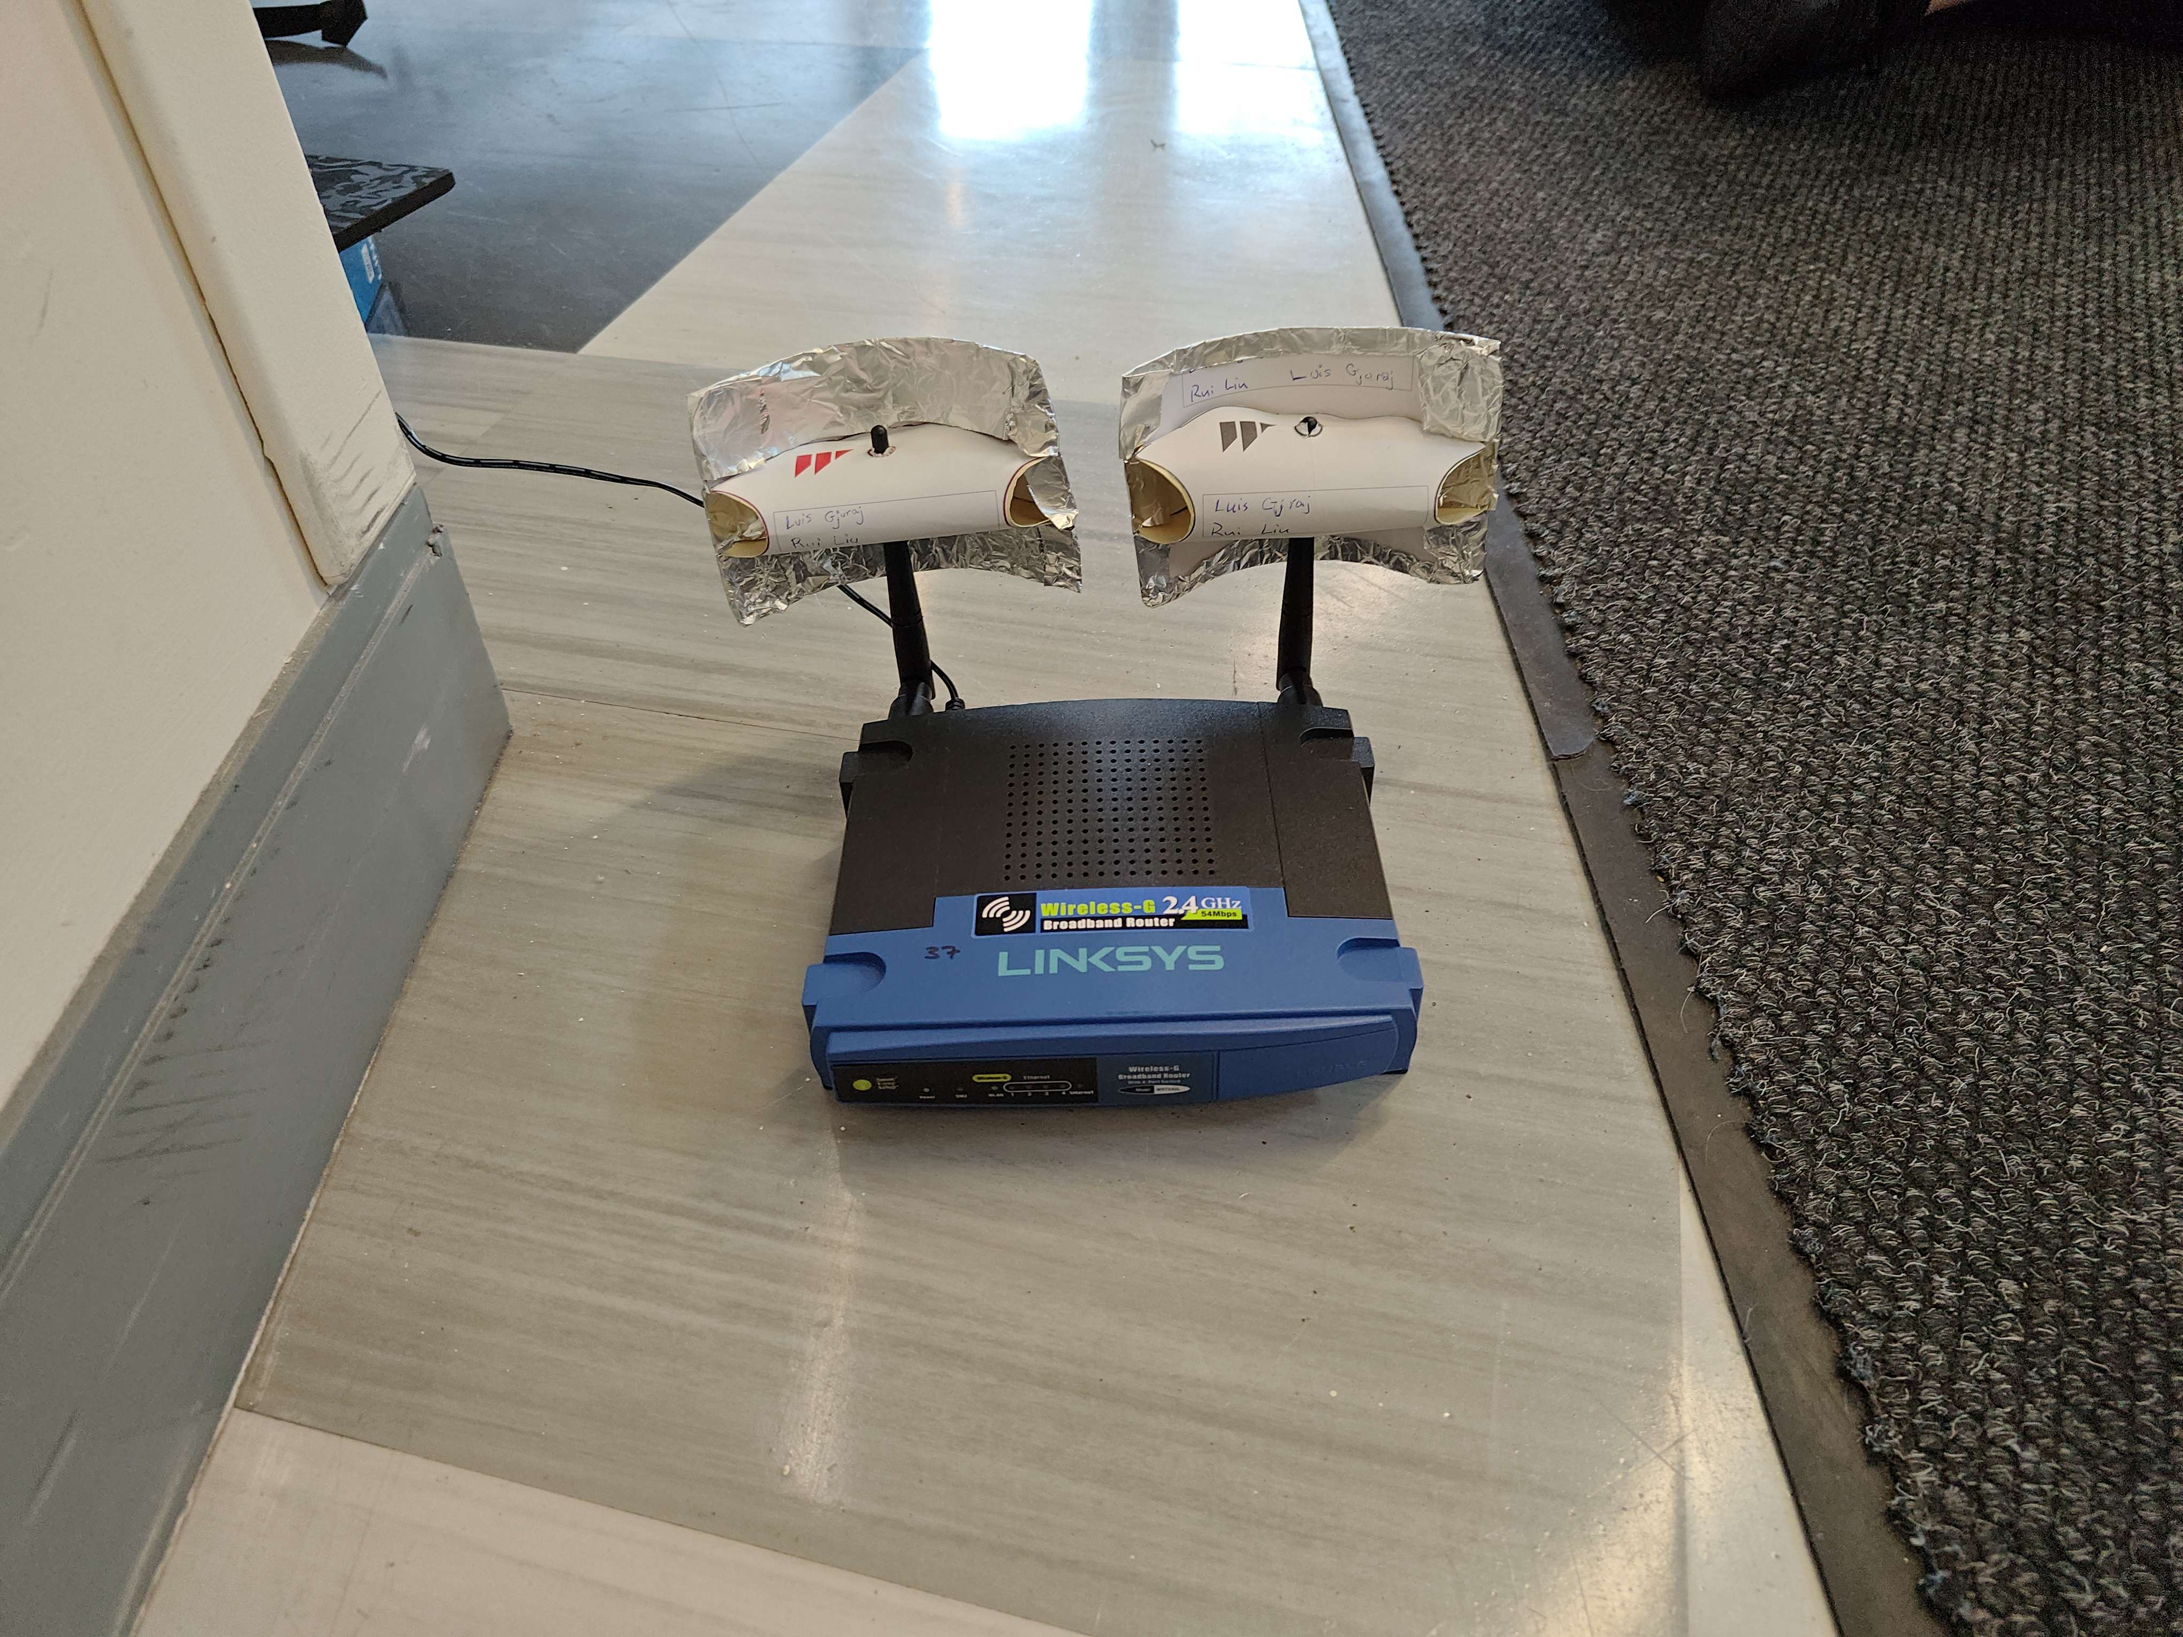

**Without Windsurfers:**

|  |  |  |  |  |  |  |
| --- | --- | --- | --- | --- | --- | --- |
| **Txpwr NO WINDSURFER** | **Signal Level (dBm)** | | | | | |
|  | Trial 1 | Trial 2 | Trial 3 | Trial 4 | Average | Distance (m) |
| Power and control lab | -59 | -57 | -59 | -59 | -58 | 17.9832 |
| Electrical Room 3-005 | -58 | -60 | -62 | -60 | -60 | 26.5176 |
| Lab Service/Storage 3-003A | -61 | -60 | -61 | -61 | -61 | 48.4632 |
| “To West Lot” sign | -65 | -63 | -65 | -67 | -65 | 61.8744 |

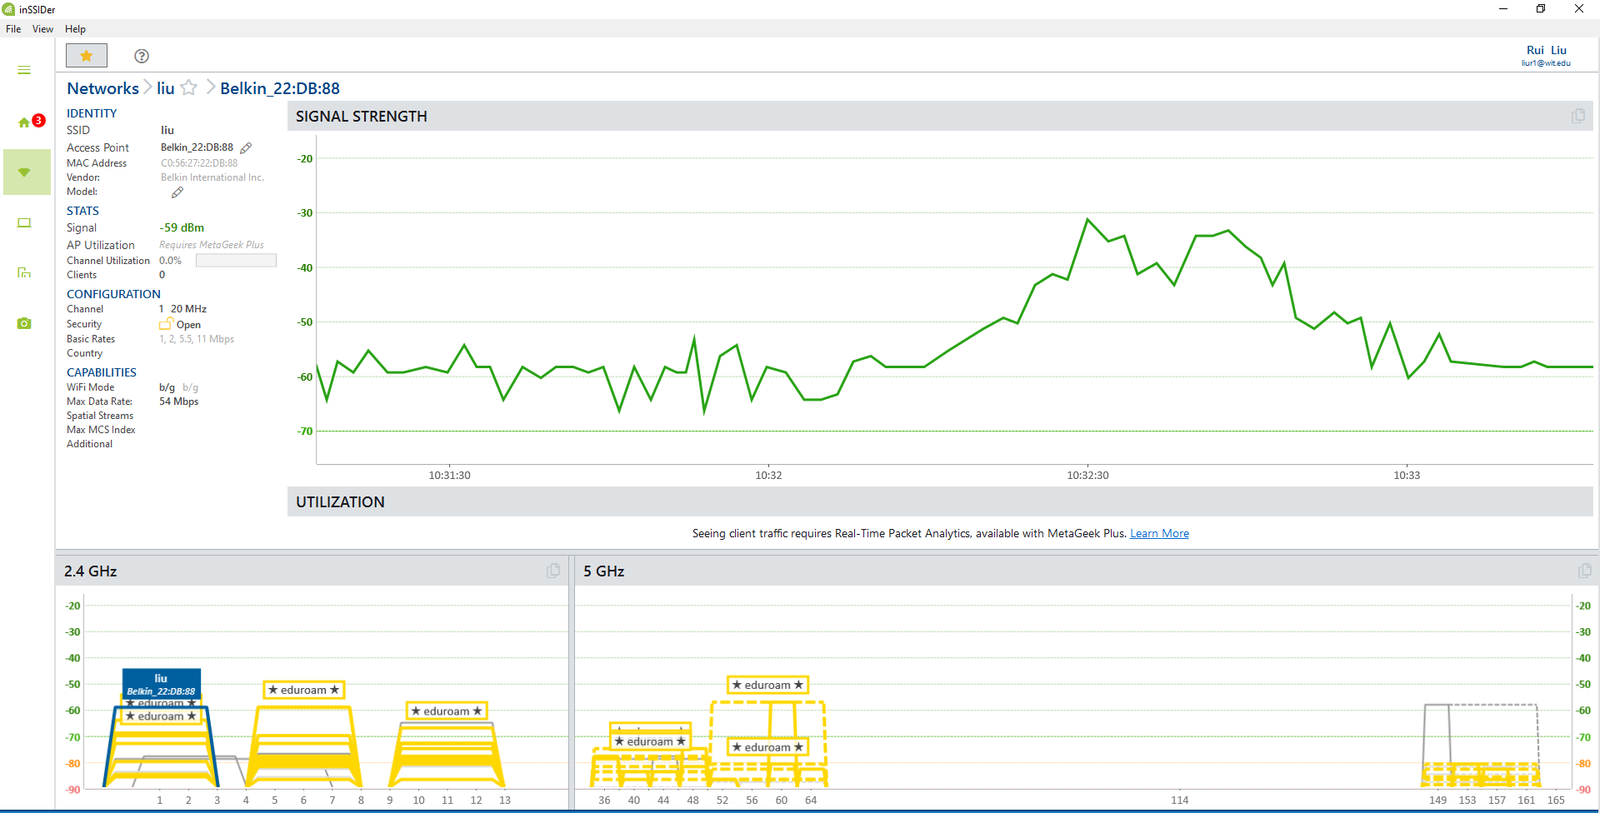

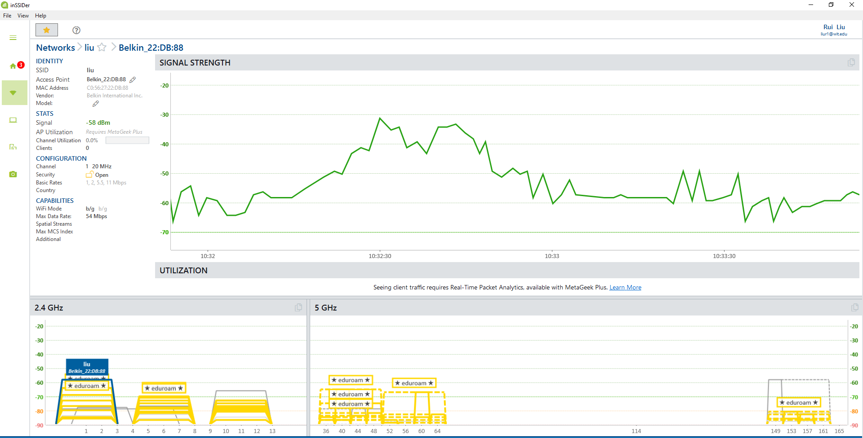

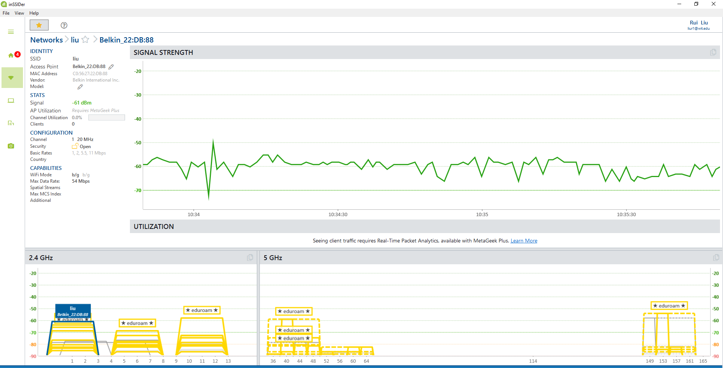

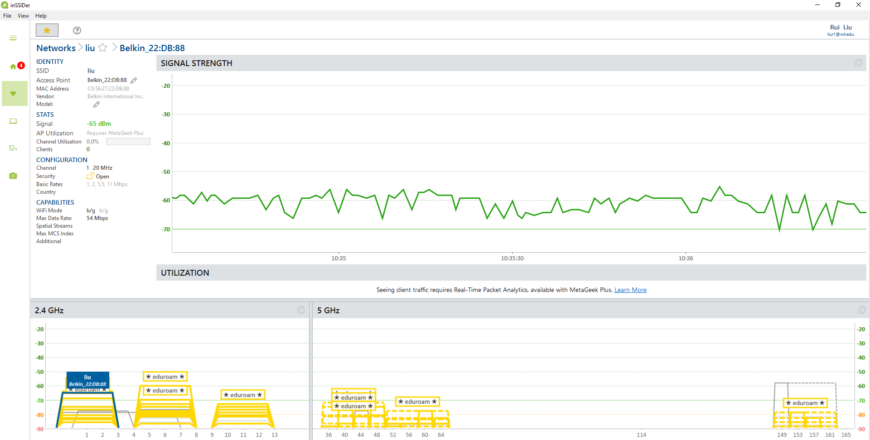

**With Windsurfers:**

|  |  |  |  |  |  |  |
| --- | --- | --- | --- | --- | --- | --- |
| **Txpwr with WINDSURFER** | **Signal Level (dBm)** | | | | | |
|  | Trial 1 | Trial 2 | Trial 3 | Trial 4 | Average | Distance (m) |
| Power and control lab | -50 | -49 | -50 | -51 | -50 | 17.9832 |
| Electrical Room 3-005 | -51 | -51 | -51 | -51 | -51 | 26.5176 |
| Lab Service/Storage 3-003A | -59 | -60 | -61 | -59 | -60 | 48.4632 |
| “To West Lot” sign | -61 | -62 | -61 | -61 | -61 | 61.8744 |

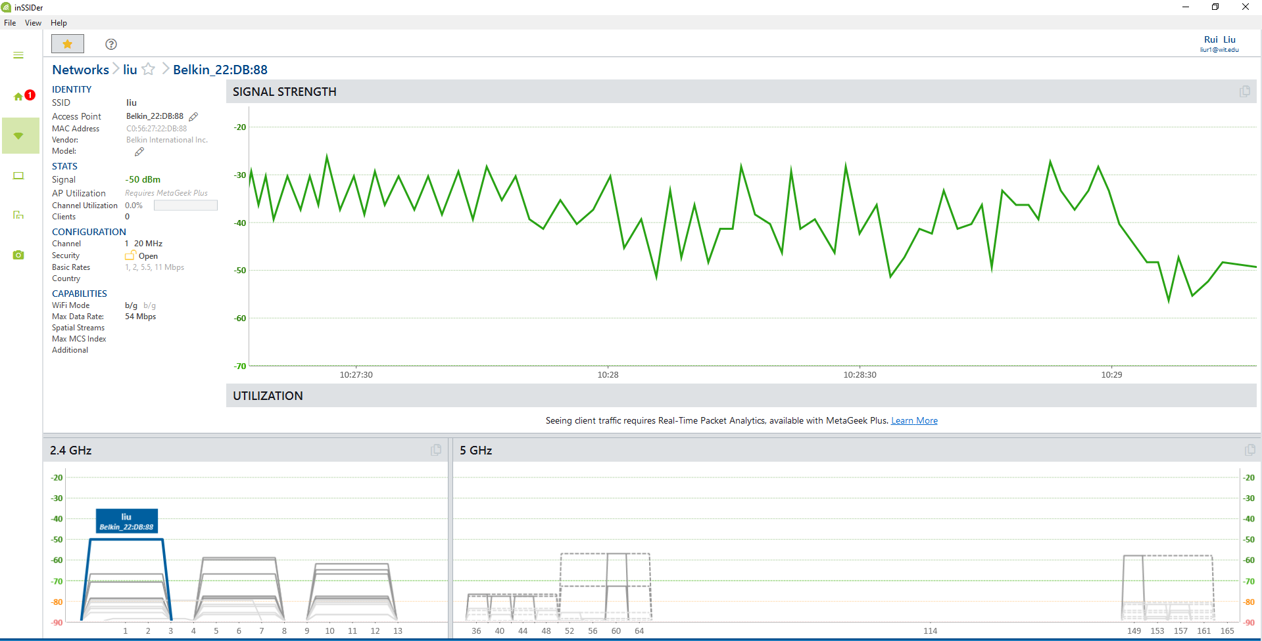

`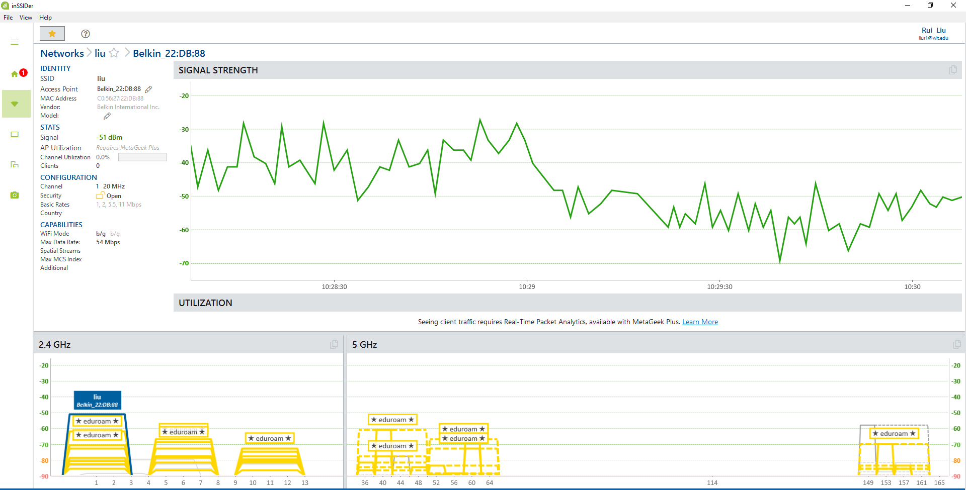

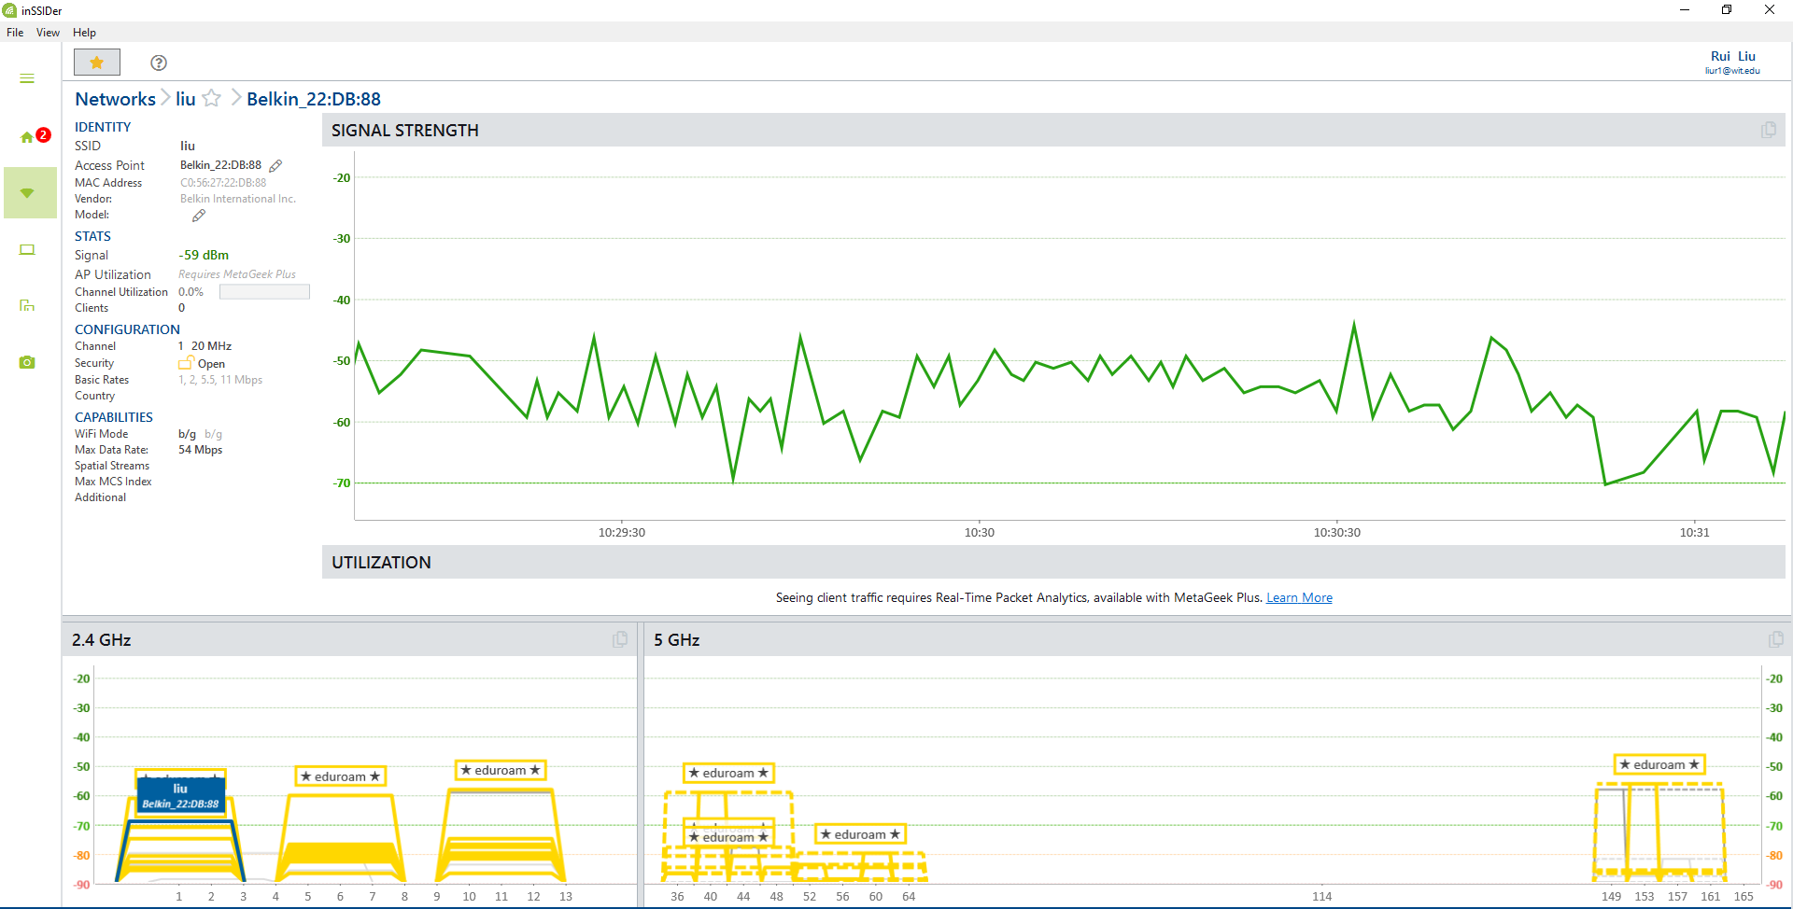

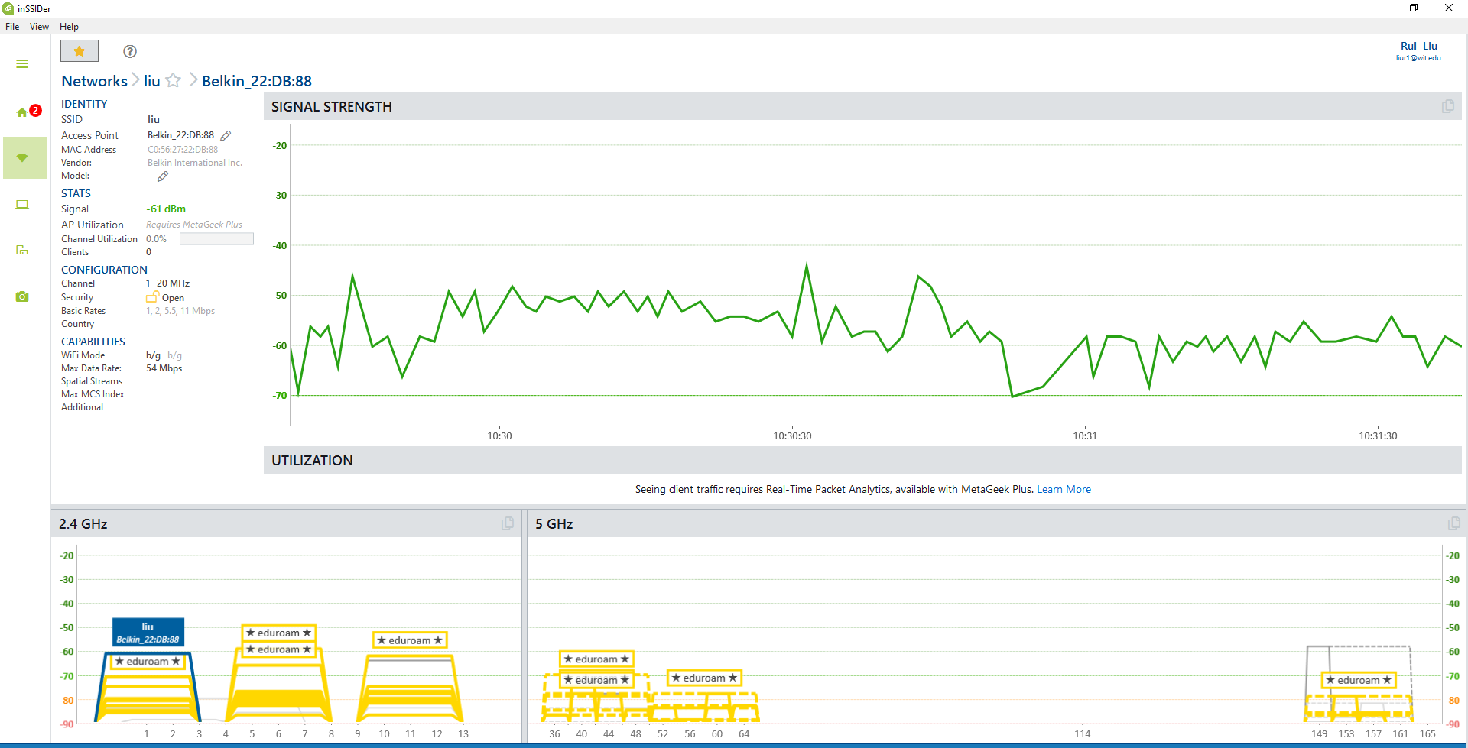

# Bonus, max range challenge (10 extra points)

You may work in groups of two for the bonus part. But I still need individual submission and your partner’s name.

**Objective:** See how far you can go in the hallway until the average signal strength goes below -80dBm. This is where the signal strength become unreliable. You may go around the corner at the other end of the hallway.

You may also play with the direction of your windsurfer angle and or height and or size of it, as long as your router is at the designated location (see above).

You need to be able to reproduce your results again to be eligible for the extra points.

The team with the longest range will win this challenge.

Luis & Rui - No thanks.